WT CASE STUDY
Project Title:
Restaurant Food Order System

Team Members
1. G.Nirmal Kumar(121810318003)
2. P.Sai Swaroop(121810318013)
3. M.Venkata Sanjay(121810318015)
4. B.Sai Prabhat(121810318044)
5. P.Rajesh(121810318045)
6. R.Likith(121810318059)

Abstract
The aim of the project was to build a responsive online web application for restaurant which helps customers to order food online. The system also allows to quickly and easily manage an online menu which customers can browse and use to place orders with just few clicks.

Introduction
The customers of today are attracted to online food ordering system not only because of placing an order online is very convenient but also because they have visibility into the items offered, price and simplified navigation for the order.
Customer can choose one or more items to place an order which will land in the Cart. Customer can view all the order details in the cart before checking out. At the end, customer gets order confirmation details. Once the order is placed it is entered in the database and retrieved in pretty much real time. This allows Restaurant Employees to quickly go through the orders as they are received and all orders are processed efficiently and effectively with no delay.

Technologies used:
- Front-end:
- HTML
- CSS
- JAVASCRIPT

- Back-end
- DJANGO Framework
- MySQL (Database)

HTML :
<!--Homepage-->
<!DOCTYPE html>
<html lang="en">
<head>
{% load static %}
<meta charset="UTF-8">
<meta name="viewport" content="width=device-width, initial-scale=1.0">
<title>Food ordering system</title>
<link rel="stylesheet" type="text/css" href="{% static 'css/homepage.css' %}">
<link rel="stylesheet" href="https://cdnjs.cloudflare.com/ajax/libs/font-awesome/4.7.0/css/font-awesome.min.css">
{% block stylesheet %} {% endblock stylesheet %}
<!--<script type="text/javascript" src="{% static 'js/cartpage.js' %}" async></script>-->
<script src="https://code.jquery.com/jquery-3.1.0.min.js"></script>
<script src='https://code.jquery.com/jquery-3.2.1.min.js'></script>
{% block javascript %}{% endblock javascript %}
</head>
<body>
<section class="header">
<nav class="navbar">
<div class="navbar-box">
<h3 class="heading-tertiary"><span id="blue">Blue</span> Park restaurant</h3>
</div>

<ul class="navbar-list">
<!--
<li class="navbar-item">
<a href="#menucall" class="navbar-link-book">Order now</a>
</li>
-->
<li class="navbar-item">
<a href="#cartspan" class="navbar-link-book1"><i class="fa fa-shopping-cart" >Cart</i></a>
</li>
<li class="navbar-item">
<a href="{% url 'survey' %}" class="navbar-link-book1">Feedback</a>
</li>
{% if user.is_authenticated %}

<li class="navbar-item">
<span style="color: white;">Hi, {{user.username}}</span>
<a href="{% url 'logout' %}" class="navbar-link-book1">Logout</a>
</li>
{% else %}
<li class="navbar-item">
<a href="{% url 'register' %}" class="navbar-link-book1">Register</a>
</li>
<li class="navbar-item">
<a href="{% url 'login' %}" class="navbar-link-book1">Login</a>
</li>
{% endif %}
</ul>
</nav>
<div class="header-container">
<div class="video">
<video loop muted autoplay id="video">
<source src="{% static 'images/video.mp4' %}" type="video/mp4">
</video>
</div>
<div class="header-box">
<h1 class="heading-primary">
Best <br> <span id="restaurant">Restaurant</span> <br> in Vizag
</h1>
<a href="#menucall" class="book-now">Order Now</a>
</div>
</div>
</section>
<span id="menucall"></span>
<section class="menu" id="menu">
<script type="text/javascript" src="{% static 'js/theme.js' %}"></script>
<button id="mode" onclick="changeTheme()">Light Mode</button>

<div class="container">
<div class="menu-heading" id="menu-heading">Menu</div>
</div>
<h1 class="menu-mid" id="menu-mid">Recommended Items:</h1>
<br>
<br>
{% block content %}
<div class="menu-grid">
{% for menus in menu_items %}
{% ifequal menus.category "recommended" %}
<div class="menu-container">
<img class="menu-img imgs" src="{{menus.menuimg.url}}">
<button type="button" class="check">Add to Cart</button>
<h1 class="menu-title">{{menus.item_name}}</h1>
<p class="menu-p">{{menus.description}}</p>
<h3 class="price">{{menus.price}}</h3>₹
</div>
{% endifequal %}
{% endfor %}
</div>
<br>
<br>
<br>
<h1 class="menu-mid" id="menu-mid">Starter:</h1>
<br>
<br>
<div class="menu-grid1">
{% for menus in menu_items %}
{% ifequal menus.category "starters" %}
<div class="menu-container">
<img class="menu-img imgs" src="{{menus.menuimg.url}}">
<button type="button" class="check">Add to Cart</button>
<h1 class="menu-title">{{menus.item_name}}</h1>
<p class="menu-p">{{menus.description}}</p>
<h3 class="price">{{menus.price}}</h3>₹
</div>
{% endifequal %}
{% endfor %}
</div>
<br>
<br>
<h1 class="menu-mid" id="menu-mid">Biryani:</h1>
<br>
<div class="menu-grid1">
{% for menus in menu_items %}
{% ifequal menus.category "biriyanis" %}
<div class="menu-container">
<img class="menu-img imgs" src="{{menus.menuimg.url}}">
<button type="button" class="check">Add to Cart</button>
<h1 class="menu-title">{{menus.item_name}}</h1>
<p class="menu-p">{{menus.description}}</p>
<h3 class="price">{{menus.price}}</h3>₹
</div>
{% endifequal %}
{% endfor %}
</div>
<span id="cartspan"></span>
{% endblock %}

<br>
<br>
{% if user.is_authenticated %}
<p id="login" hidden="True">1</p>
{% else %}
<p id="login" hidden="True">0</p>
{% endif %}
<h1 class="menu-heading" id="menu-heading">Cart</h1>
<div class="display-cart">
<script type="text/javascript">
if (document.readyState == 'loading') {
document.addEventListener('DOMContentLoaded', ready)
} else {
ready()
}

function ready() {
var removeCartItemButtons = document.getElementsByClassName('fa-trash')
for (var i = 0; i < removeCartItemButtons.length; i++) {
var button = removeCartItemButtons[i]
button.addEventListener('click', removeCartItem)
}

var quantityInputs = document.getElementsByClassName('cart-quantity-input')
for (var i = 0; i < quantityInputs.length; i++) {
var input = quantityInputs[i]
input.addEventListener('change', quantityChanged)
}

var addToCartButtons = document.getElementsByClassName('check')
for (var i = 0; i < addToCartButtons.length; i++) {
var button = addToCartButtons[i]
button.addEventListener('click', addToCartClicked)
}

document.getElementsByClassName('btn-order')[0].addEventListener('click', purchaseClicked)
}

function purchaseClicked() {
var cartItems = document.getElementsByClassName('cart-items')[0]
while (cartItems.hasChildNodes()) {
cartItems.removeChild(cartItems.firstChild)
}
updateCartTotal()
}

function removeCartItem(event) {
var buttonClicked = event.target
buttonClicked.parentElement.parentElement.remove()
updateCartTotal()
}

function quantityChanged(event) {
var input = event.target
if (isNaN(input.value) || input.value <= 0) {
input.value = 1
}
updateCartTotal()
}

function addToCartClicked(event) {
var button = event.target
var menuItem = button.parentElement
var title = menuItem.getElementsByClassName('menu-title')[0].innerText
var price = menuItem.getElementsByClassName('price')[0].innerText
var imageSrc = menuItem.getElementsByClassName('imgs')[0].src
addItemToCart(title, price)
updateCartTotal()
}

function addItemToCart(title, price) {
var count = 0
var login = document.getElementById('login').innerText
console.log(login)
var cartRow = document.createElement('tr')
cartRow.classList.add('cart-row')
var cartItems = document.getElementsByClassName('cart-items')[0]
var cartItemNames = cartItems.getElementsByClassName('cart-item-title')
for (var i = 0; i < cartItemNames.length; i++) {
count = count + 1;
if (cartItemNames[i].innerText == title) {
alert('This item is already added to the cart')
return
}
else{
$.ajax({
url: '{% url "cart_add" %}',
data: {
'login': login,
'title': title,
'price': price,
'count': (count>=1)?1:0
},
dataType: 'json',
success: function (data) {
if (data) {

}
}
});
}
}

var cartRowContents = `
<td class="cart-item-title">${title}</td>
<td class="cart-quantity">
<input class="cart-quantity-input" type="number" value="1" max="6">
</td>
<td>
<span class="cart-note"><input type="text" class="txt1"></span>
<i class="fa fa-trash fa-2x"></i>
</td>
<td class="cart-price cart-column">${price}
</td>
`

cartRow.innerHTML = cartRowContents
cartItems.append(cartRow)
cartRow.getElementsByClassName('fa-trash')[0].addEventListener('click', removeCartItem)
cartRow.getElementsByClassName('cart-quantity-input')[0].addEventListener('change', quantityChanged)

}

function updateCartTotal() {
var cartItemContainer = document.getElementsByClassName('cart-items')[0]
var cartRows = cartItemContainer.getElementsByClassName('cart-row')
var total = 0
for (var i = 0; i < cartRows.length; i++) {
var cartRow = cartRows[i]
var priceElement = cartRow.getElementsByClassName('cart-price')[0]
var quantityElement = cartRow.getElementsByClassName('cart-quantity-input')[0]
var price = parseFloat(priceElement.innerText.replace('$', ''))
var quantity = quantityElement.value
total = total + (price * quantity)
}
total = Math.round(total * 100) / 100
document.getElementsByClassName('cart-total-price')[0].innerText = total+'₹'
}

</script>
<table id="cart-table" class="cart-items">
<tr>
<th>ITEM</th>
<th>QUANTITY</th>
<th>NOTE</th>
<th>PRICE</th>
</tr>
</table>
<div class="cart-total">
<strong class="cart-total-title">Total:&nbsp;</strong>
<span class="cart-total-price">0₹</span>
</div>
</div>
<!--Don't forget to change the path of hyperlinks-->
{% if user.is_authenticated %}
<a href="{% url 'checkout' %}"><button class="btn-order" type="button">Continue To Checkout</button></a>
{% else %}
<a href="{% url 'login'%}"><button class="btn-order" type="button">Continue To Checkout</button></a>
{% endif %}
</section>
<footer>
<div class="footer">
<div class="footer-content">

<div class="footer-section about">
<h1 class="logo-text"><span>Blue</span>Park</h1>
<p>
Launched in Vizag, BluePark has grown from a home project to one of the largest food aggregators in the Vizag.
We are enabling our vision of better food for more people. We not only connect people to food in every context but work closely with restaurants to enable a sustainable ecosystem.
</p>
</div>
<div class="footer-section links">
<div class="div2">
<h2>Quick Links</h2>
<br>
<ul>
<a href="#"><li>Events</li></a>
<a href="#"><li>Team</li></a>
<a href="#"><li>Mentors</li></a>
<a href="#"><li>Gallery</li></a>
<a href="#"><li>Terms and conditions</li></a>
</ul>
</div>
</div>
<div class="footer-section contact-form">
<h2>Contact Us</h2>
<br>
<div class="contact">
<span>9666765999</span><br>
<span>info@Bluepark.com</span><br>
<br>
<h2>Follow Us on</h2>
<br>
<a href="#" class="fa fa-facebook"></a>
<a href="#" class="fa fa-twitter"></a>
<a href="#" class="fa fa-youtube"></a>
<a href="#" class="fa fa-instagram"></a>
<a href="#" class="fa fa-google"></a>
</div>
</div>
</div>
<div class="footer-bottom" style="font-size: large;">
&copy; bluerestuarant.com |Designed by B18 members
</div>
</div>
</footer>
</body>

</html>

<!--Registration Page-->
<!DOCTYPE html>
<html lang="en-US">
<html>
{% load static %}
<head>
<title>Bluepark Restaurant | Register</title>
<link rel="stylesheet" type="text/css" href="{% static 'css/register.css' %}">
<script type="text/javascript" src="{% static 'js/register.js' %}"></script>
</head>
<body>
<header>
<div class="restitle">
<h1>BluePark</h1>
</div>
</header>
<div class="loginbox">
<img src="{% static 'images/p2.jpg' %}" class="avatar">
<h1 class="regtitle">Register</h1>
<form method="post" onsubmit="return validate()">
{% csrf_token %}
<p>Username</p>
<input type="text" id="uname" name="uname" placeholder="Enter new username" required>
<p>Email</p>
<input type="mail" id="mail" name="mail" placeholder="Enter your mail id" required>
<p>New Password</p>
<input type="password" id="pwd" name="pwd" placeholder="Enter password" required>
<p>Confirm Password</p>
<input type="password" id="pwd1" name="pwd1" placeholder="Confirm password" required>
<input type="submit" name="register" value="register">
</form>
<button type="button" class="backlogin"><a href="{% url 'login'%}">Back to Login</a></button>
<div class="message">
{% for message in messages %}
<h3 id="messages" style="text-align:center;">{{message}}</h3>
{% endfor %}
</div>
</div>
</body>
</html>

<!--Login Page-->
<!DOCTYPE html>
<html lang="en-US">
<html>
{% load static %}
<head>
<title>Bluepark Restaurant | Login</title>
<link rel="stylesheet" type="text/css" href="{% static 'css/login.css' %}">
</head>
<body>
<header>
<div class="restitle">
<h1>BluePark</h1>
</div>
</header>
<div class="loginbox">
<img src="{% static 'images/p2.jpg'%}" class="avatar">
<h1>Login Here</h1>
<form method="POST">
{% csrf_token %}
<p>Username</p>
<input type="text" id="uname" name="uname" placeholder="Enter Username" required>
<p>Password</p>
<input type="password" name="pwd" placeholder="Enter Password" required>
<input type="submit" value="Login">
<a href="{% url 'update' %}">Update Password</a><br>
<a href="{% url 'register' %}">Don't have an Account- SIGN UP</a><br>
<a href="{% url 'admin:index' %}">Admin Login</a>
</form>
<div class="message">
{% for message in messages %}
<h3 id="messages" style="text-align:center;">{{message}}</h3>
{% endfor %}
</div>
</div>
</body>
</html>

<!--Update Page-->
<!DOCTYPE html>
<html lang="en-US">
<html>
{% load static %}
<head>
<title>Bluepark Restaurant | Update Password</title>
<link rel="stylesheet" type="text/css" href="{% static 'css/register.css' %}">
<script type="text/javascript" src="{% static 'js/register.js' %}"></script>
</head>
<body>
<header>
<div class="restitle">
<h1>BluePark</h1>
</div>
</header>
<div class="loginbox">
<img src="{% static 'images/p2.jpg' %}" class="avatar">
<h1>Update Password</h1>
<form method="post" onsubmit="return validate()">
{% csrf_token %}
<p>Username</p>
<input type="text" id="uname" name="uname" placeholder="Enter username" required>
<p>Current Password</p>
<input type="password" id="password" name="password" placeholder="Enter current password" required>
<p>New Password</p>
<input type="password" id="pwd" name="pwd" placeholder="Enter new password" required>
<p>Confirm New Password</p>
<input type="password" id="pwd1" name="pwd1" placeholder="Enter New password again" required>
<input type="submit" name="update" value="Update Password">
</form>
<button type="button" class="backlogin"><a href="{% url 'login'%}">Back to Login</a></button>
<div class="message">
{% for message in messages %}
<h3 id="messages" style="text-align:center;">{{message}}</h3>
{% endfor %}
</div>
</div>
</body>
</html>

<!--Checkout-->
<html>
<head>
{% load static %}
<meta name="viewport" content="width=device-width, initial-scale=1">
<script type="text/javascript" src="{% static 'js/checkout.js' %}"></script>
<link rel="stylesheet" href="https://cdnjs.cloudflare.com/ajax/libs/font-awesome/4.7.0/css/font-awesome.min.css">
{% block stylesheet %} {% endblock stylesheet%}
<link rel="stylesheet" type="text/css" href="{% static 'css/checkout.css' %}">

</head>
<body>
<div class="row">
<div class="col-75">
<div class="container">
<form action="" method="post" onsubmit="return validate()">
{% csrf_token %}
<div class="row">
<div class="col-50">
<h3>Delivery Address</h3>
<label for="fname"><i class="fa fa-user"></i> Full Name</label>
<input type="text" id="fname" name="firstname" placeholder="Enter Full Name" required>
<label for="adr"><i class="fa fa-address-card-o"></i> Address</label>
<input type="text" id="adr" name="address" placeholder="Enter Address" required>
<label for="city"><i class="fa fa-institution"></i> City</label>
<input type="text" id="city" name="city" placeholder="Vizag" disabled>

<div class="row">
<div class="col-50">
<label for="state">State</label>
<input type="text" id="state" name="state" placeholder="Andhra Pradesh" disabled>
</div>
<div class="col-50">
<label for="zip">Pincode</label>
<input type="text" id="zip" name="zip" placeholder="Enter Pincode" required>
</div>
<div class="col-50">
<label for="phone">Phone number</label>
<input type="tel" id="phone" name="phone" pattern="[0-9]{10}" placeholder="Enter Phone number" required>
</div>
</div>
</div>

<div class="col-50">
<h3>Payment</h3>
<label for="fname">Accepted Cards</label>
<div class="icon-container">
<i class="fa fa-cc-visa" style="color:navy;"></i>
<i class="fa fa-cc-amex" style="color:blue;"></i>
<i class="fa fa-cc-mastercard" style="color:red;"></i>
<i class="fa fa-cc-discover" style="color:orange;"></i>
</div>
<label for="cname">Name on Card</label>
<input type="text" id="cname" name="cardname" placeholder="Enter your Card Name">
<label for="ccnum">Credit card number</label>
<input type="text" id="ccnum" name="cardnumber" placeholder="Enter Your Card Number">
<label for="expmonth">Expiry Month</label>
<input type="text" id="expmonth" name="expmonth" placeholder="Enter Card Expiry Month ">

<div class="row">
<div class="col-50">
<label for="expyear">Expiry Year</label>
<input type="text" id="expyear" name="expyear" placeholder="Enter Card Expiry Year">
</div>
<div class="col-50">
<label for="cvv">CVV</label>
<input type="password" id="cvv" name="cvv" placeholder="Enter Your CVV">
</div>
</div>
</div>

</div>
<label>
<input type="checkbox" name="cod" id="cod" onclick="paymentDisable()"> Cash On Delivery
</label>
<script type="text/javascript">

function paymentDisable()
{
var cod = document.getElementById("cod");
if(cod.checked==true){
document.getElementById("cname").disabled = true;
document.getElementById("ccnum").disabled = true;
document.getElementById("expmonth").disabled = true;
document.getElementById("expyear").disabled = true;
document.getElementById("cvv").disabled = true;
}
else{
document.getElementById("cname").disabled = false;
document.getElementById("ccnum").disabled = false;
document.getElementById("expmonth").disabled = false;
document.getElementById("expyear").disabled = false;
document.getElementById("cvv").disabled = false;
}
}
</script>

<input type="submit" value="Confirm Order" class="btn" >
</form>
</div>
</div>

<div class="col-25">
<div class="container">
<h4>Cart&nbsp;&nbsp;&nbsp;&nbsp;&nbsp;&nbsp;&nbsp;&nbsp;&nbsp;&nbsp;&nbsp;&nbsp;&nbsp;&nbsp;&nbsp;&nbsp;Qty
<span class="price" style="color:black">
<i class="fa fa-shopping-cart"></i>
<b>4</b>
</span>
</h4>
<p>Product 1&nbsp;&nbsp;&nbsp;&nbsp;&nbsp;&nbsp;&nbsp;&nbsp;&nbsp; <span class="qty">1</span> <span class="price">15Rs.</span></p>
<p>Product 2&nbsp;&nbsp;&nbsp;&nbsp;&nbsp;&nbsp;&nbsp;&nbsp;&nbsp; <span class="qty">2</span> <span class="price">5Rs.</span></p>
<p>Product 3&nbsp;&nbsp;&nbsp;&nbsp;&nbsp;&nbsp;&nbsp;&nbsp;&nbsp; <span class="qty">1</span> <span class="price">8Rs.</span></p>

<hr>
<p>Total <span class="price" style="color:black"><b>30rs</b></span></p>
</div>
</div>
</div>
</body>
</html>

<!—Waiting Form-->
<html>
<head>
{% load static %}
<link rel="stylesheet" type="text/css" href="{% static 'css/waiting.css' %}">
<script>
setTimeout(function(){
window.location.href ="{% url 'survey' %}";
}, 16000);
var timeleft = 15;
var downloadTimer = setInterval(function(){
if(timeleft <= 0){
clearInterval(downloadTimer);
document.getElementById("countdown").innerHTML = "Finished";
} else {
document.getElementById("countdown").innerHTML = timeleft + " seconds remaining";
}
timeleft -= 1;
}, 1000);
</script>
</head>
<body>
<div class="ti">
<h1 style="color: white;"> <span style="color: teal;">Blue</span>Park Restaurant
</h1>
<h1>Thank You for your Purchase</h1>
<p>Please Leave your Valuable Feedback</p>
<p>You will be directed to Survey Form in <span id="countdown"></span>
</div>
</body>
</html>

<!--Survey Form-->
<!DOCTYPE html>
<html lang="en" dir="ltr">
{% load static %}
<head>
<title>Website Survey Form</title>
<meta name='viewport' content='width=device-width, initial-scale=1'>
<script src='https://kit.fontawesome.com/a076d05399.js'></script>
{% block javascript %}{% endblock javascript%}
<link rel="stylesheet" href="{% static 'css/surveyForm.css' %}">
</head>
<body>
<script src="{% static 'js/surveyValidate.js' %}"></script>
<div class="whole">
<div class="header">
<a href="{% url 'login' %}" target="_blank">www.Bluepark.com</a>
<h1>Website Survey Form</h1>
<p>Thank you for using our Website :)<br>
Kindly fill up this survey, this will just take 3 minutes of your time.<br>
This survey will help us to provide you much better optimized services.</p>
</div>
<div class="surveyForm">
<form name="survey" action="" method="POST" onsubmit="return validate()">
{% csrf_token %}
<div class="formdiv">
<p>Have you ever heard of our Restaurant before?</p>
<div class="radio11">
<input type="radio" name="heard" id="yes" value="yes">
<label for="yes">Yes</label>
</div>
<div class="radio12">
<input type="radio" name="heard" id="no" value="no">
<label for="no">No</label>
</div>
<br><br>
<p>Where did you came to know about our Restaurant?</p>
<select name="platforms">
<option value="Newspaper">Newspaper</option>
<option value="Ads">Advertisements</option>
<option value="sms">SMS</option>
<option value="friends">Friends</option>
<option value="osource" selected="selected">Other source</option>
</select>
<p>What is your name?</p>
<input type="text" name="username" id="username" placeholder="Enter your name">
<br>
<p>Have you ordered anything in our website?</p>
<div class="radio21">
<input type="radio" name="purchase" id="yes2" value="True"><label for="yes2">Yes</label>
</div>
<div class="radio22">
<input type="radio" name="purchase" id="no2" value="False"><label for="no2">No</label>
</div>
<br><br>
<p>What are your favourite food items in our Restaurant?</p>
<input type="text" name="favourite" id="favourite" placeholder="Enter your favourite food items">
<br><br>
<p>Enter your Mail-id to receive exciting promotional offers</p>
<input type="mail" name="email" id="email" placeholder="Enter your E-mail address">
<br><br>
<p>How much do you rate for our website on a scale(0-5)?</p>
<br>
<input type="range" name="rating" id="rating" class="slider" min="0" max="5" value="0">
<p id="colorchange">Rating: <span id="disprange"></span></p>
<i id="emoji" class='far fa-angry' style="font-size:48px"></i>
<br>
<script>
var slider = document.getElementById('rating');
var display = document.getElementById('disprange');
var emoji = document.getElementById('emoji');
display.innerHTML = slider.value;
x=document.getElementById('colorchange');
x.style.color="#c90000";
slider.oninput = function(){
display.innerHTML = this.value;
if(this.value=="0"||this.value=="1"){
x.style.color="#c90000";
emoji.className = "far fa-frown";
}
else if(this.value=="2"||this.value=="3"){
x.style.color="#de4707";
}
else if(this.value=="4"||this.value=="5"){
x.style.color="#059c1b";
}
if(this.value=="0")
emoji.className = "far fa-angry";
else if(this.value=="1")
emoji.className = "far fa-frown";
else if(this.value=="2")
emoji.className = "far fa-frown-open";
else if(this.value=="3")
emoji.className = "far fa-grin";
else if(this.value=="4")
emoji.className = "far fa-grin-beam";
else
emoji.className = "far fa-grin-hearts";
}
</script>
<p>Please write your feedback on our services </p>
<textarea maxlength="300" name="feedback" id="feedback" rows="10" cols="100" placeholder="Maximum limit:150 characters"></textarea>
<br><br>
<input id="reset" type="reset" name="reset">
<input id="submit" type="submit" name="submit">
<br><br>
</div>
</form>
</div>
</div>
</body>
</html>

CSS Files:
/*Homepage*/
*{
padding: 0;
margin: 0;
box-sizing: border-box;
}

html{
font-size: 62.5%;
}
#blue{
color:skyblue;
}
body{
font-family: 'popons', sans-serif;
background-color: rgb(27,27,27);
overflow-x: hidden;
user-select: none;
}

.header{
height: 90vh;
position: relative;
}

.navbar{
height: 110px;
width: 100%;
background-color: black;
display: flex;
justify-content: space-between;
align-items: center;
padding: 0 40px;
z-index: 10;
position: fixed;
}

.navbar-box{
display: flex;
align-items: center;
font-size: 2rem;
color: white;
}

.heading-tertiary{
font-size: 3.5rem;
}

.navbar-list{
list-style: none;
font-size: 2rem;
}

.navbar-item{
display: inline-block;
}

.navbar-link:visited,
.navbar-link:link{
text-decoration: none;
color: white;
padding: 3rem;
transition: all .2s ease;
}

.navbar-link:hover{
background-color: #da6b1d;
color: white;
}

.navbar-link-book:visited,
.navbar-link-book:link{
text-decoration: none;
color: white;
padding: 2rem 3.5rem;
border: 1px solid #da6b1d;
border-radius: 200px;
box-shadow: 0 0 1rem rgba(236, 118, 40, .5);
text-shadow: 0 .3rem 1rem rgba(255,255,255, .5);
transition: all .4s ease;
margin-left:20px;
}

.navbar-link-book:hover{
background-color: #da6b1d;
color: white;
}
.navbar-link-book1{
position: relative;
text-decoration: none;
color: white;
font-size:20px;
transition: all .4s ease;
cursor:pointer;
margin-left: 20px;
margin-right:20px;
}
.navbar-link-book1:hover{
color:orange;

}
.toggle div{
height: 4px;
width: 100%;
background-color: white;
margin: 1rem;
}

.header-container{
width: 100%;
height: 100%;
background-size: cover;
color: white;
}

.video{
width: 100%;
height: 100%;
background-color: rgba(0,0,0,.4);
position: absolute;
bottom: 0;
right: 0;
}

#video{
width: 100%;
height: 100%;
object-fit: cover;
position: relative;
z-index: -1;
}

.header-box{
position: absolute;
top: 50%;
left: 50%;
transform: translate(-50%, -50%);
text-align: center;
text-transform: uppercase;
color: white;
}

.heading-primary{
font-size: 6.5rem;
font-weight: 600;
letter-spacing: 3px;
margin-top: 10%;
}

#restaurant{
color: #da6b1d;
font-weight: 800;
font-size: 8rem;
}

.lead{
font-size: 1.9rem;
font-weight: 600;
letter-spacing: 4px;
}

.book-now:visited,
.book-now:link{
text-decoration: none;
display: inline-block;
color: white;
font-size: 2rem;
padding: 2rem;
margin-top: 4rem;
border: 1px solid white;

border-radius: 100px;
transition: all .3s ease;
box-shadow: 0 1rem 1rem rgba(240,107,55, .1);
text-shadow: 0 1rem 1rem rgba(0,0,0,.6);
}

.book-now:hover{
background-color: #da6b1d;
border: 1px solid white;
box-shadow: 0 0 2rem rgba(240,107,55, .8);
}

#menu{
width: 100%;
padding: 10rem 5rem;
background-color:orangered;
}

#menu-heading{
font-size: 80px;
text-align: center;
text-shadow: 0 0 1rem rgba(0,0,0,.9);
text-transform: uppercase;
color: white;
font-weight: 500;
}
.menu-grid1{
display: grid;
grid-template-rows:repeat(1, 1fr) ;
grid-template-columns: repeat(4, 1fr);
justify-self: center;
grid-gap: 2rem;
margin:0;
}
.menu-grid{
display: grid;
grid-template-rows:repeat(2, 1fr) ;
grid-template-columns: repeat(4, 1fr);
justify-self: center;
grid-gap: 2rem;
margin:0;
}
#menu-mid{
font-size: 4rem;
text-align: center;
text-shadow: 0 0 1rem rgba(0,0,0,.9);
text-transform: uppercase;
color: white;
font-weight: 800;
margin:0;
}
.heading-secondary{
font-size: 7rem;
text-transform: uppercase;
color: white;
text-align: center;
}

.menu-img{
height: 50%;
width: 100%;
background-size: cover;
background-position: left;
}

.menu-container{
width: 100%;
height: 50rem;
background-color: white;
border-radius: 5px;
overflow: hidden;
box-shadow: 0 0 2rem rgba(0,0,0,.2);
transition: all .4s ease;
margin:0;
}

.menu-container:hover{
box-shadow: 0 0 5rem rgba(0,0,0,.4);
transform: scale(1.07);
}

.menu-p{
font-size: 1.4rem;
padding: 1rem;
text-align: center;
}

.menu-title{
font-size: 3rem;
text-align: center;
}

.price{
font-size: 3rem;
margin-top: 1rem;
text-align: center;
color: #da6b1d;
text-shadow: 0 .4rem 2rem rgba(0,0,0,.4);
}
.check{
position: relative;
left:45%;
top: 40%;
background-color: Orange;
border: none;
color: white;
padding: 15px 30px;
text-decoration: none;
display: inline-block;
font-size: 16px;
cursor: pointer;
}
.check:hover{
background-color:red;
}

.gg{
background-color: #4CAF50; /* Green */
border: none;
color: white;
padding: 10px 15px;
text-align: center;
text-decoration: none;
display: inline-block;
font-size: 16px;
margin: 4px 2px;
cursor: pointer;
background-color: white;
color: black;
border: 2px solid black;
font-size:20px;
}
.txt{
height: 40px;
font-size:20px;
}
.footer {
background: #303036;
color: #d3d3d3;
height: 400px;
position: relative;
}

.footer .footer-content {

height: 350px;
display: flex;
}

.footer .footer-content .footer-section{
flex: 1;
padding: 25px;

}
.footer .footer-content h1,
.footer .footer-content h2{
color:white;
font-size: 30px;
}
.footer .footer-content .about h1 span{
color: #05f7ff;

}
.footer .footer-content .about p{
color: white;
font-size: 20px;
}
.footer .footer-content .about .contact span{
display: block;
font-size: 20px;
margin-bottom: 8px;
}
.footer .footer-content .links ul a{
display: block;
margin-bottom: 10px;
font-size: 20px;
color:white;
}
.footer .footer-content .links ul a:hover{
color:skyblue;
margin-left: 15px;
transition: all.3s;
}
.footer .footer-bottom {
background: #343a40;
color: #686868;
height: 50px;
width: 100%;
text-align: center;
position: absolute;
bottom: 0px;
left: 0px;
padding-top: 20px;
}
.footer .footer-content .contact-form .contact{
font-size: 20px;
}
h2{
font-size: 20px;
}
.div2{
margin-left: 23%;
}
a{
list-style: none;
}
.fa {
padding: 10px;
font-size: 38px;
width: 40px;
text-align: center;
text-decoration: none;
margin: 5px 2px;
border-radius: 50%;
}

.fa-facebook:hover {
opacity: 0.7;
color:blue;
background-color: white;
}
.fa-twitter:hover {
opacity: 0.7;
color:teal;
background-color: white;
}
.fa-youtube:hover {
opacity: 0.7;
color:red;
background-color: white;
}
.fa-instagram:hover {
opacity: 0.7;
color:blueviolet;
background-color: white;
}
.fa-google:hover {
opacity: 0.7;
color:orangered;
background-color: white;
}
.fa-facebook {
background: #3B5998;
color: white;
}

.fa-twitter {
background: #55ACEE;
color: white;
}

.fa-google {
background: #dd4b39;
color: white;
}

.fa-youtube {
background: #bb0000;
color: white;
}

.fa-instagram {
background: #125688;
color: white;
}

.display-cart {
width: auto;
height: auto;
margin: 80px auto;
background: #FFFFFF;
box-shadow: 1px 2px 3px 0px rgba(0,0,0,0.10);
border-radius: 6px;
position: static;
display: flex;
flex-direction: column;
}

.cart-items th{
padding: 10px;
background-color: black;
color: white;
font-size: 20px;
border: 2px solid white;
}
#cart-table tr{
text-align: center;
border: 1px solid white;
}

.cart-items tr,td{
font-size: 20px;
border-spacing: 15px;
border: 2px solid #ab4100;
border-collapse: collapse;
text-align: center;
}
.cart-total-title{
font-size: 20px;
margin-left: 87%;
}
.cart-total-price{
font-size: 20px;
}
.cart-item-title{

font-size: 20px;
}
.cart-quantity-input{
margin-left: 10%;
font-size: 20px;
text-align: center;
align-items: center;
}
input[type="number"]{
width:100px;
border: none;

}
.cart-note input[type="text"]{
width:200px;
height: 30px;
margin-bottom: 30px;
}
.cart-price{
font-size: 20px;
}
.btn-danger{
size:30px;
}
table{
font-family: arial, sans-serif;
border-collapse: collapse;
}

.cart-quantity-input input,.cart-quantity-input button{
width:50px;
padding:.5em;
font-size:1.2rem;
text-align:center;
font-weight:900;
background:white;
border:1px solid #aaa;
}

.cart-quantity-input input{
border-left:none;
border-right:none;
}

#mode{
border-radius: 2px;
border:1px solid black;
outline:none;
background-color: white;

}
#mode:hover{
border:1px solid white;
background-color:black;
color:white;
}

a{
text-decoration:none;
}

a .btn-order{
float: right;
cursor: pointer;
background-color: white;
border:none;
outline:none;
border-radius: 2px;
padding: 10px;
}
a .btn-order:hover{
background-color:red;
color:white
}

/*Registration Page*/
body{
margin: 0;
padding: 0;
background: url('../images/p1.jpg');
background-size: cover;
font-family: sans-serif;
user-select: none;
}

.loginbox{
width: 320px;
height: 510px;
background: #000;
color: #fff;
top: 50%;
left: 50%;
position: absolute;
transform: translate(-50%,-50%);
box-sizing: border-box;
padding: 70px 30px;
}

.avatar{
width: 100px;
height: 100px;
border-radius: 50%;
position:absolute;
top: -50px;
left: calc(50% - 50px);
}
.regtitle{
text-align: center;
font-size: 20px;
}
h1{
margin: 0;
padding: 0 0 20px;
/*text-align: center;*/
font-size: 24px;
}

.loginbox p{
margin: 0;
padding: 0;
font-weight: bold;
}

.loginbox input{
width: 100%;
margin-bottom: 20px;
}

.loginbox input[type="text"], input[type="password"], input[type="mail"]
{
border: none;
border-bottom: 1px solid #fff;
background: transparent;
outline: none;
height: 40px;
color: #fff;
font-size: 16px;
}

.loginbox input[type="submit"]
{
border: none;
outline: none;
height: 40px;
background: #fb2525;
color: #fff;
font-size: 18px;
border-radius: 20px;
}

.loginbox input[type="submit"]:hover
{
cursor: pointer;
background: #ffc107;
color: #000;
}

header
{
color: blueviolet;
background-color: black;
font-weight: bold;
font-size: 40px;

}
.message
{

background-color: #000;
height: auto;
width: auto;
}
a
{
text-decoration: none;
color: white;
}
button
{
background-color: #fb2525;
color: white;
border-radius: 10%;
}
button:hover
{
background-color: teal;
}

/*Login Page*/
body{
margin: 0;
padding: 0;
background-image: url("../images/p1.jpg");
background-size: cover;
font-family: sans-serif;
user-select: none;
}

.loginbox{
width: 320px;
height: 420px;
background: #000;
color: #fff;
top: 50%;
left: 50%;
position: absolute;
transform: translate(-50%,-50%);
box-sizing: border-box;
padding: 70px 30px;
}

.avatar{
width: 100px;
height: 100px;
border-radius: 50%;
position:absolute;
top: -50px;
left: calc(50% - 50px);
}

h1{
margin: 0;
padding: 0 0 20px;
text-align: center;
font-size: 22px;
}

.loginbox p{
margin: 0;
padding: 0;
font-weight: bold;
}

.loginbox input{
width: 100%;
margin-bottom: 20px;
}

.loginbox input[type="text"], input[type="password"]
{
border: none;
border-bottom: 1px solid #fff;
background: transparent;
outline: none;
height: 40px;
color: #fff;
font-size: 16px;
}

.loginbox input[type="submit"]
{
border: none;
outline: none;
height: 40px;
background: #fb2525;
color: #fff;
font-size: 18px;
border-radius: 20px;
}

.loginbox input[type="submit"]:hover
{
cursor: pointer;
background: #ffc107;
color: #000;
}

.loginbox a{
text-decoration: none;
font-size: 12px;
line-height: 20px;
color: darkgrey;
}

.loginbox a:hover
{
color: #ffc107;
}
header
{
color: blueviolet;
background-color: black;
font-weight: bold;
font-size: 40px;
}
.message
{
background-color: #000;
height: auto;
width: auto;
}
/*Checkout Page*/
body {
background: url(https://www.lironboylston.com/wp-content/uploads/2020/12/WBC_7095.jpg);
font-family: Arial;
font-size: 17px;
padding: 8px;
user-select: none;
}

* {
box-sizing: border-box;
}

.row {
display: -ms-flexbox; /* IE10 */
display: flex;
-ms-flex-wrap: wrap; /* IE10 */
flex-wrap: wrap;
margin: 0 -16px;
}

.col-25 {
-ms-flex: 25%; /* IE10 */
flex: 25%;
}

.col-50 {
-ms-flex: 50%; /* IE10 */
flex: 50%;
}

.col-75 {
-ms-flex: 75%; /* IE10 */
flex: 75%;
}

.col-25,
.col-50,
.col-75 {
padding: 0 16px;
}

.container {
background-color: #f2f2f2;
padding: 5px 20px 15px 20px;
border: 1px solid lightgrey;
border-radius: 3px;
}

input[type=text],input[type=password],input[type=tel] {
width: 100%;
margin-bottom: 20px;
padding: 12px;
border: 1px solid #ccc;
border-radius: 3px;
}

label {
margin-bottom: 10px;
display: block;
}

.icon-container {
margin-bottom: 20px;
padding: 7px 0;
font-size: 24px;
}

.btn {
background-color: #04AA6D;
color: white;
padding: 12px;
margin: 10px 0;
border: none;
width: 100%;
border-radius: 3px;
cursor: pointer;
font-size: 17px;
}

.btn:hover {
background-color: #45a049;
}

a {
color: #2196F3;
}

hr {
border: 1px solid lightgrey;
}

span.price {
float: right;
color: grey;
}

/* Responsive layout - when the screen is less than 800px wide, make the two columns stack on top of each other instead of next to each other (also change the direction - make the "cart" column go on top) */
@media (max-width: 800px) {
.row {
flex-direction: column-reverse;
}
.col-25 {
margin-bottom: 20px;
}
}
.qty
{
text-align: center;
}

/*Waiting Page*/
body{
margin: 0;
padding: 0;
background-image: url('../images/p1.jpg');
background-size: cover;
font-family: sans-serif;
}

.ti{
margin: 0;
padding: 0 0 20px;
text-align: center;
font-size: 25px;
color:black;
font-weight:bold;
background-color:darkorange;
}

/*Survey Form*/
body{
display: block;
background-color: #0a0909;
user-select: none;
}
a{
color: blue;
}
#submit,#reset{
background-color: black;
border: 1px solid black;
outline: none;
color: white;
padding: 6px 22px;
text-align: center;
text-decoration: none;
display: inline-block;
font-size: 16px;
}
#submit:hover,#reset:hover{
color: black;
background-color: #0e4bad;
outline: none;
border:none;
}
.header{
text-align: center;
font-family:sans-serif;
font-size: 22px;
color: darkgrey;
}
.surveyForm{
border: 2px solid black;
}
.formdiv{
margin-left: 25%;
margin-right: 25%;
border: 2px solid black;
text-align: center;
background-color: darkgrey;
color: black;
}
.formdiv p{
font-size: 22px;
font-family:cursive;
}
form{
color: #9ae1f5;
font-size: 20px;
font-family:cursive;
}
.slider{
width: 240px;

}
.slider::-webkit-slider-thumb {
-webkit-appearance: none;
appearance: none;
width: 23px;
height: 24px;
border: 0;
background: url('contrasticon.png');
cursor: pointer;
}

.slider::-moz-range-thumb {
width: 23px;
height: 25px;
border: 0;
background: url('contrasticon.png');
cursor: pointer;
color: black;
}
input[type=text], input[type=number], input[type=mail], select {
width: 60%;
padding: 12px 20px;
font-size: 18px;
margin: 8px 0;
display: inline-block;
font-family:Georgia;
border: 1px solid #ccc;
border-radius: 4px;
background-color: #c7d6c8;
box-sizing: border-box;
outline: none;
}
input[type=text]:hover, input[type=number]:hover, input[type=mail]:hover,select:hover {
border: 2px solid #238226;
padding: 10px 18px;
outline: none;
}
textarea{
resize:none;
width: 80%;
font-size: 18px;
outline: none;
background-color: #c7d6c8;
border-radius: 8px;
font-family:Verdana;
}
p{
font-size: 25px;
font-family:monospace;
font-weight: bolder;
}

.radio11{
position: absolute;
transform: translate(-60%,-40%);
left: 45%;
}
.radio12{
position: absolute;
transform: translate(-60%,-40%);
left: 55%;
}
input[type="radio"]{
display: none;
}
#yes+label{
position: relative;
color: black;
font-family: 'Poppins',sans-serif;
border: 2px solid black;
border-radius: 5px;
padding: 6px 20px;
display:flex;
align-items: center;
cursor: pointer;
margin-top: 5%;
}
#no+label{
position: relative;
color: black;
font-family: 'Poppins',sans-serif;
border: 2px solid black;
border-radius: 5px;
padding: 6px 20px;
display: flex;
align-items: center;
cursor: pointer;
margin-top: 5%;
}

#yes+label:before{
content: "";
height: 20px;
width: 20px;
border: 3px solid black;
border-radius: 50%;
margin-right: 25px;
}
#no+label:before{
content: "";
height: 20px;
width: 20px;
border: 3px solid black;
border-radius: 50%;
margin-right: 25px;
}
#yes:checked+label{
background-color: #01cc65;
color: white;
}
#yes:checked+label:before{
height: 10px;
width: 10px;
border: 10px solid white;
background-color: #01cc65;
}
#no:checked+label{
background-color: #f20f2d;
color: white;
}
#no:checked+label:before{
height: 10px;
width: 10px;
border: 10px solid white;
background-color: #f20f2d;
}
.radio21{
position: absolute;
transform: translate(-60%,-40%);
left: 45%;
}
.radio22{
position: absolute;
transform: translate(-60%,-40%);
left: 55%;
}
#yes2+label{
position: relative;
color: black;
font-family: 'Poppins',sans-serif;
border: 2px solid black;
border-radius: 5px;
padding: 6px 20px;
display: flex;
align-items: center;
cursor: pointer;
margin-top: 5%;
}
#no2+label{
position: relative;
color: black;
font-family: 'Poppins',sans-serif;
border: 2px solid black;
border-radius: 5px;
padding: 6px 20px;
display: flex;
align-items: center;
cursor: pointer;
margin-top: 5%;
}
#yes2+label:before{
content: "";
height: 20px;
width: 20px;
border: 3px solid black;
border-radius: 50%;
margin-right: 25px;
}
#no2+label:before{
content: "";
height: 20px;
width: 20px;
border: 3px solid black;
border-radius: 50%;
margin-right: 25px;
}
#yes2:checked+label{
background-color: #01cc65;
color: white;
}
#yes2:checked+label:before{
height: 10px;
width: 10px;
border: 10px solid white;
background-color: #01cc65;
}
#no2:checked+label{
background-color: #f20f2d;
color: white;
}
#no2:checked+label:before{
height: 10px;
width: 10px;
border: 10px solid white;
background-color: #f20f2d;

}

Java Script Files:
/*Homepage*/
/*Theme*/
function changeTheme(){
var iname = document.getElementById("mode").innerText;
if(iname=="Light Mode"){
document.getElementById("menu").style.background="#999696";
//document.getElementById("menu-mid").style.color="black";
//document.getElementById("menu-heading").style.color="black";
document.getElementById("mode").innerText = "Dark Mode";
}
else if(iname=="Dark Mode")
{
document.getElementById("menu").style.background="red";
document.getElementById("mode").innerText = "Light Mode";
}
console.log(iname)
}

/*Cart*/
if (document.readyState == 'loading') {
document.addEventListener('DOMContentLoaded', ready)
} else {
ready()
}

function ready() {
var removeCartItemButtons = document.getElementsByClassName('fa-trash')
for (var i = 0; i < removeCartItemButtons.length; i++) {
var button = removeCartItemButtons[i]
button.addEventListener('click', removeCartItem)
}

var quantityInputs = document.getElementsByClassName('cart-quantity-input')
for (var i = 0; i < quantityInputs.length; i++) {
var input = quantityInputs[i]
input.addEventListener('change', quantityChanged)
}

var addToCartButtons = document.getElementsByClassName('check')
for (var i = 0; i < addToCartButtons.length; i++) {
var button = addToCartButtons[i]
button.addEventListener('click', addToCartClicked)
}

document.getElementsByClassName('btn-order')[0].addEventListener('click', purchaseClicked)
}

function purchaseClicked() {
var cartItems = document.getElementsByClassName('cart-items')[0]
while (cartItems.hasChildNodes()) {
cartItems.removeChild(cartItems.firstChild)
}
updateCartTotal()
}

function removeCartItem(event) {
var buttonClicked = event.target
buttonClicked.parentElement.parentElement.remove()
updateCartTotal()
}

function quantityChanged(event) {
var input = event.target
if (isNaN(input.value) || input.value <= 0) {
input.value = 1
}
updateCartTotal()
}

function addToCartClicked(event) {
var button = event.target
var menuItem = button.parentElement
var title = menuItem.getElementsByClassName('menu-title')[0].innerText
var price = menuItem.getElementsByClassName('price')[0].innerText
var imageSrc = menuItem.getElementsByClassName('imgs')[0].src
addItemToCart(title, price)
updateCartTotal()
}

function addItemToCart(title, price) {
var cartRow = document.createElement('tr')
cartRow.classList.add('cart-row')
var cartItems = document.getElementsByClassName('cart-items')[0]
var cartItemNames = cartItems.getElementsByClassName('cart-item-title')
for (var i = 0; i < cartItemNames.length; i++) {
if (cartItemNames[i].innerText == title) {
alert('This item is already added to the cart')
return
}
else{

}
}
}

var cartRowContents = `
<td class="cart-item-title">${title}</td>
<td class="cart-quantity">
<input class="cart-quantity-input" type="number" value="1" max="6">
</td>
<td>
<span class="cart-note"><input type="text" class="txt1"></span>
<i class="fa fa-trash fa-2x"></i>
</td>
<td class="cart-price cart-column">${price}
</td>
`

cartRow.innerHTML = cartRowContents
cartItems.append(cartRow)
cartRow.getElementsByClassName('fa-trash')[0].addEventListener('click', removeCartItem)
cartRow.getElementsByClassName('cart-quantity-input')[0].addEventListener('change', quantityChanged)

}

function updateCartTotal() {
var cartItemContainer = document.getElementsByClassName('cart-items')[0]
var cartRows = cartItemContainer.getElementsByClassName('cart-row')
var total = 0
for (var i = 0; i < cartRows.length; i++) {
var cartRow = cartRows[i]
var priceElement = cartRow.getElementsByClassName('cart-price')[0]
var quantityElement = cartRow.getElementsByClassName('cart-quantity-input')[0]
var price = parseFloat(priceElement.innerText.replace('$', ''))
var quantity = quantityElement.value
total = total + (price * quantity)
}
total = Math.round(total * 100) / 100
document.getElementsByClassName('cart-total-price')[0].innerText = total+'₹'
}

/*Register Page*/
function validate(){
var uname = document.getElementById('uname');
var alphanum = /^[A-Za-z1-9]+$/;
if(uname.value.trim()==""||!uname.value.match(alphanum))
{
alert("Please Enter valid name!");
return false;
}
if(uname.value.length<5||uname.value.length>14)
{
alert("Length of your name should be in the range of 5 and 14!!!");
return false;
}
if(document.getElementById('pwd').value.length<8) {
alert("minimum length of password is 8!!");
return false;
}
var p1 = document.getElementById('pwd');
var p2 = document.getElementById('pwd1');
if(p1.value==p2.value){
return true;
}
else {
alert("passwords did not match!!");
return false;
}
var regxmail = /^\S+@\S+\.\S+$/;
if(!regxmail.test(mail.value))
{
alert("Enter the valid email!");
return false;
}
}

/*Checkout Page*/
function validate(){
var uname = document.getElementById('fname');
var letters = /^[A-Za-z]+$/;
if(uname.value.trim()==""||!uname.value.test(letters))
{
alert("Please Enter valid name!");
return false;
}
if(document.getElementById('ccnum').value.length<16||document.getElementById('ccnum').value.length>16)
{
alert("Length of your card number should be 16!!!");
return false;
}
if(document.getElementById('expmonth').value<1||document.getElementById('expmonth').value>12)
{
alert("please enter valid month!!");
return false;
}
if(document.getElementById('expyear').value.length<4||document.getElementById('expyear').value.length>4||document.getElementById('expyear').value<2021)
{
alert("please enter valid year!!");
return false;
}

if(document.getElementById('cvv').value.length<3||document.getElementById('cvv').value.length>3)
{
alert("please enter valid cvv!!");
return false;
}
}

/*Survey Validation Form*/
function validate(){
var uname = document.getElementById('username');
var letters = /^[A-Za-z]+$/;
if(uname.value.trim()==""||!uname.value.test(letters))
{
alert("Please Enter valid name!");
return false;
}
if(uname.value.length<3||uname.value.length>16)
{
alert("Length of your name should be in the range of 3 and 16!!!");
return false;
}
var mail = document.getElementById('email');
if(mail.value.trim()=="")
{
alert("Please Enter your Mail-id");
return false;
}
var regxmail = /^\S+@\S+\.\S+$/;
if(!regxmail.test(mail.value)){
alert("Enter the valid email");
return false;
}
var heard = document.querySelector( 'input[name="heard"]:checked');
if(heard == null){
alert("Select all the options!");
return false;
}
var purchase = document.querySelector( 'input[name="purchase"]:checked');
if(purchase == null){
alert("Select all the options!");
return false;
}
var feedback = document.getElementById('feedback');
if(feedback.value==''){
alert("Please enter your response in feedback field!!");
return false;
}
if(document.getElementById('rating').value==0){
alert("Minimum rating you can provide is 1 !");
return false;
}
if(document.getElementById('favourite').value.length<=3||document.getElementById('favourite').value.length>100){
alert("Please let us know your favourite food items within length of 100 characters!!");
return false;
}
}

Django File-structure:

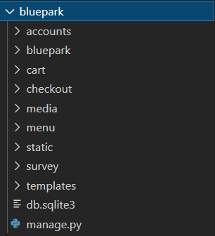

In the above diagram, ‘bluepark’ is my project root directory which was the name of the project and restaurant. In this project directory there are several folders. In the ‘bluepark’ folder which exists inside the root directory, all configurations of the project will be there and we can change all those configurations using ‘settings.py’ file. All settings related to database connectivity can also be modified in ‘settings.py’ file. I had used MySQL for storing database instead of SQLite which was the default one provided by the django. In the ‘templates’ folder, all HTML files will be there. In the ‘static’ folder, all images, CSS, and Javascript files will be there. ‘media’ folder also contains some images that are stored in the database through MySQL. All remaining folders/modules are apps that are created in the projects which perform certain operations in the backend. For example, ‘accounts’ app is responsible for authentication of users during login of the website, registration of new users and for updating passwords for the existing users.
PRICE
NAME
QTY
Project Link for Backend:
http://bit.ly/blueparkRestaurant
Outputs:
#1 Homepage Without Login:
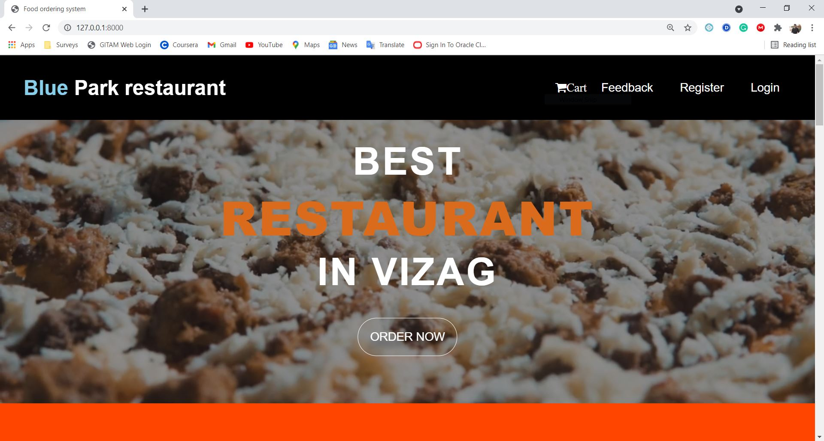
#2 Login Page:
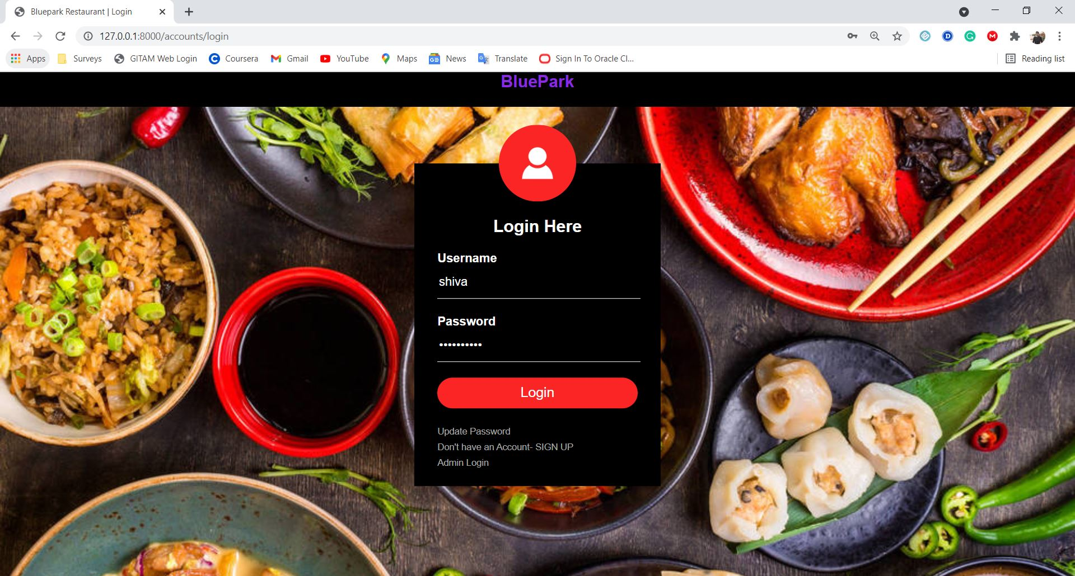

#3 Registration Page:
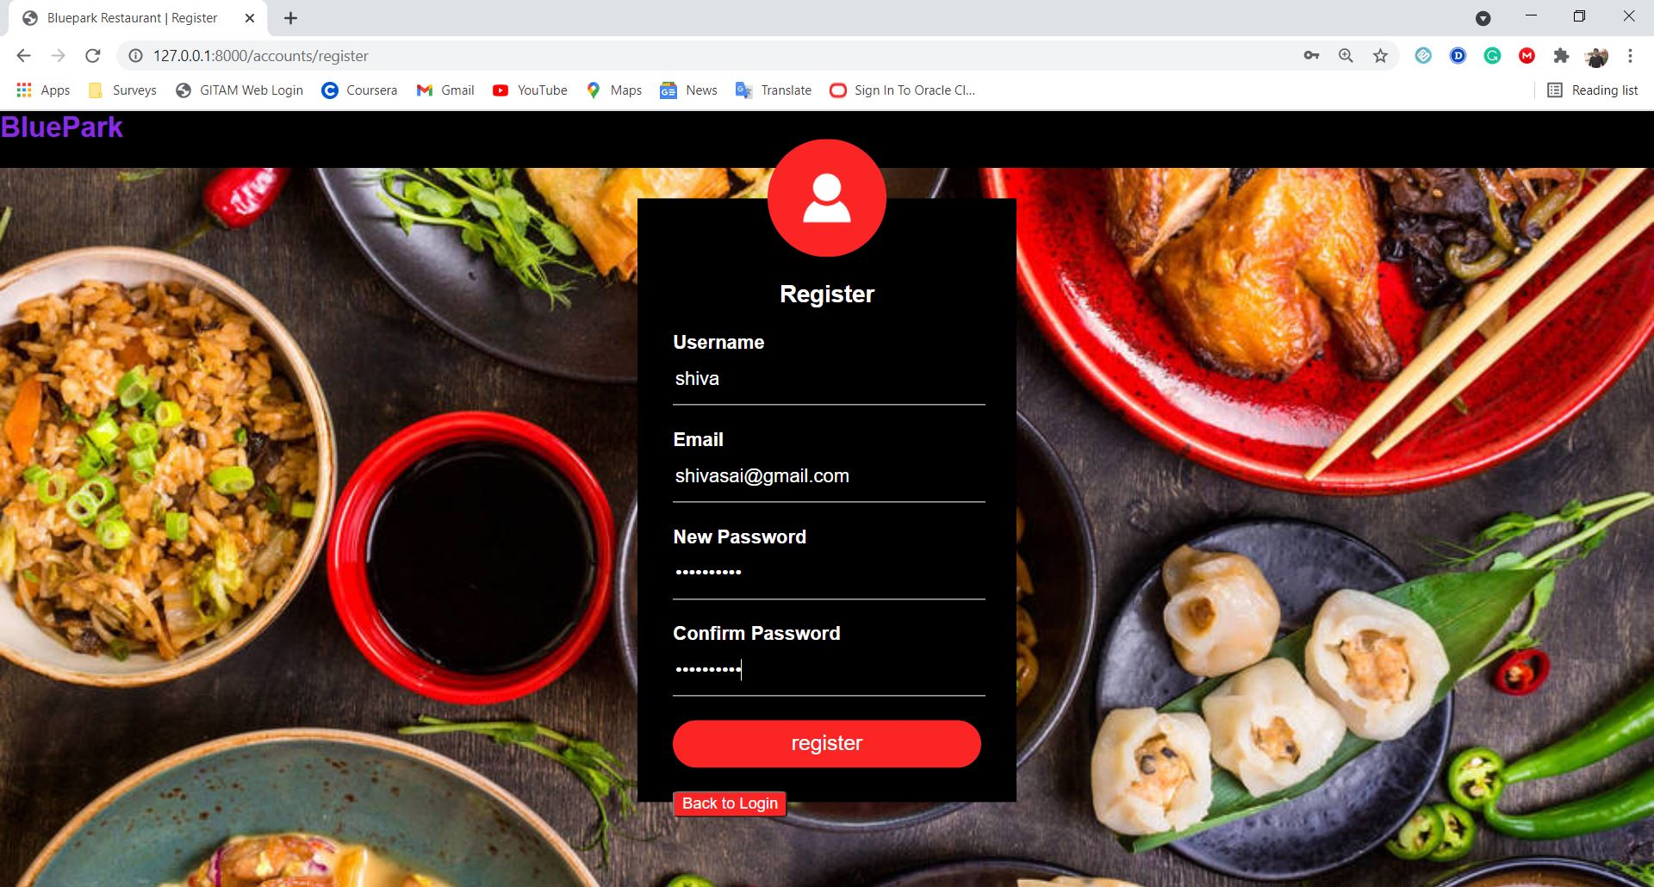

#4 Update Password Page:
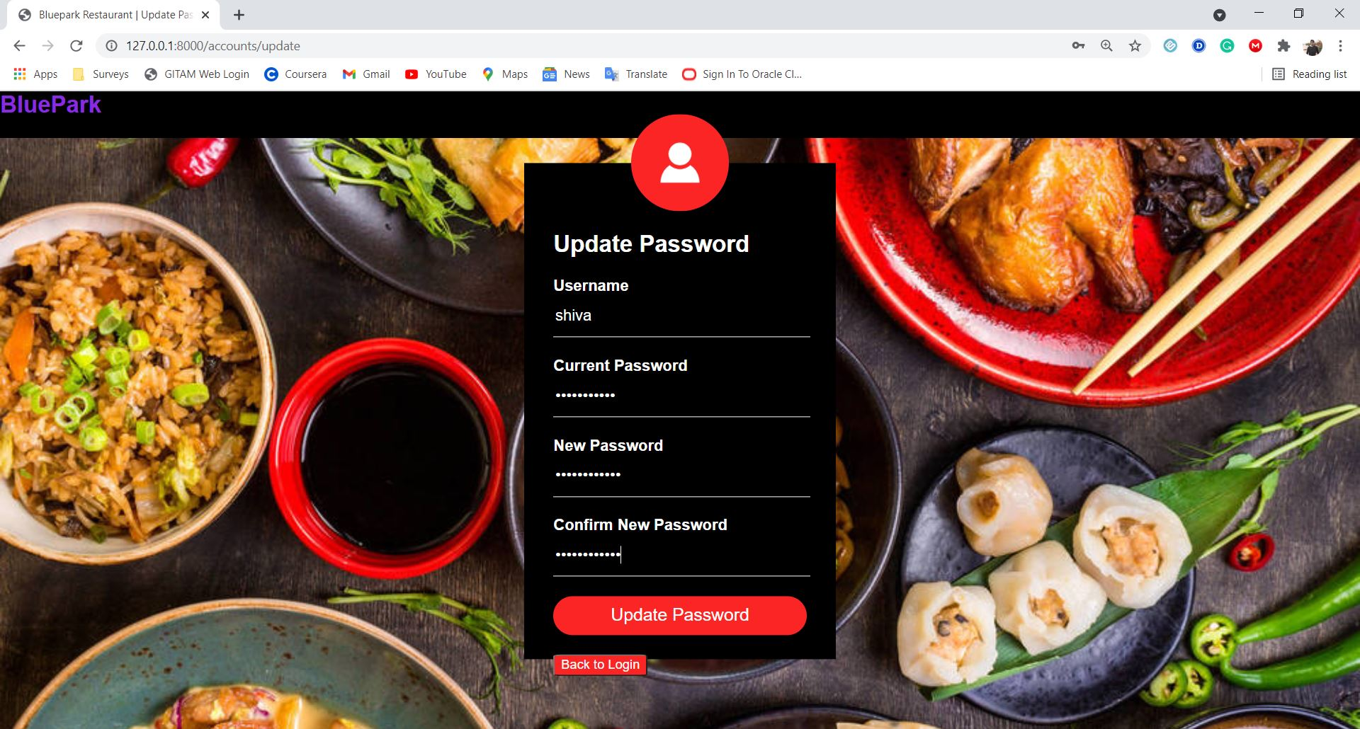

#5 Homepage After Login:
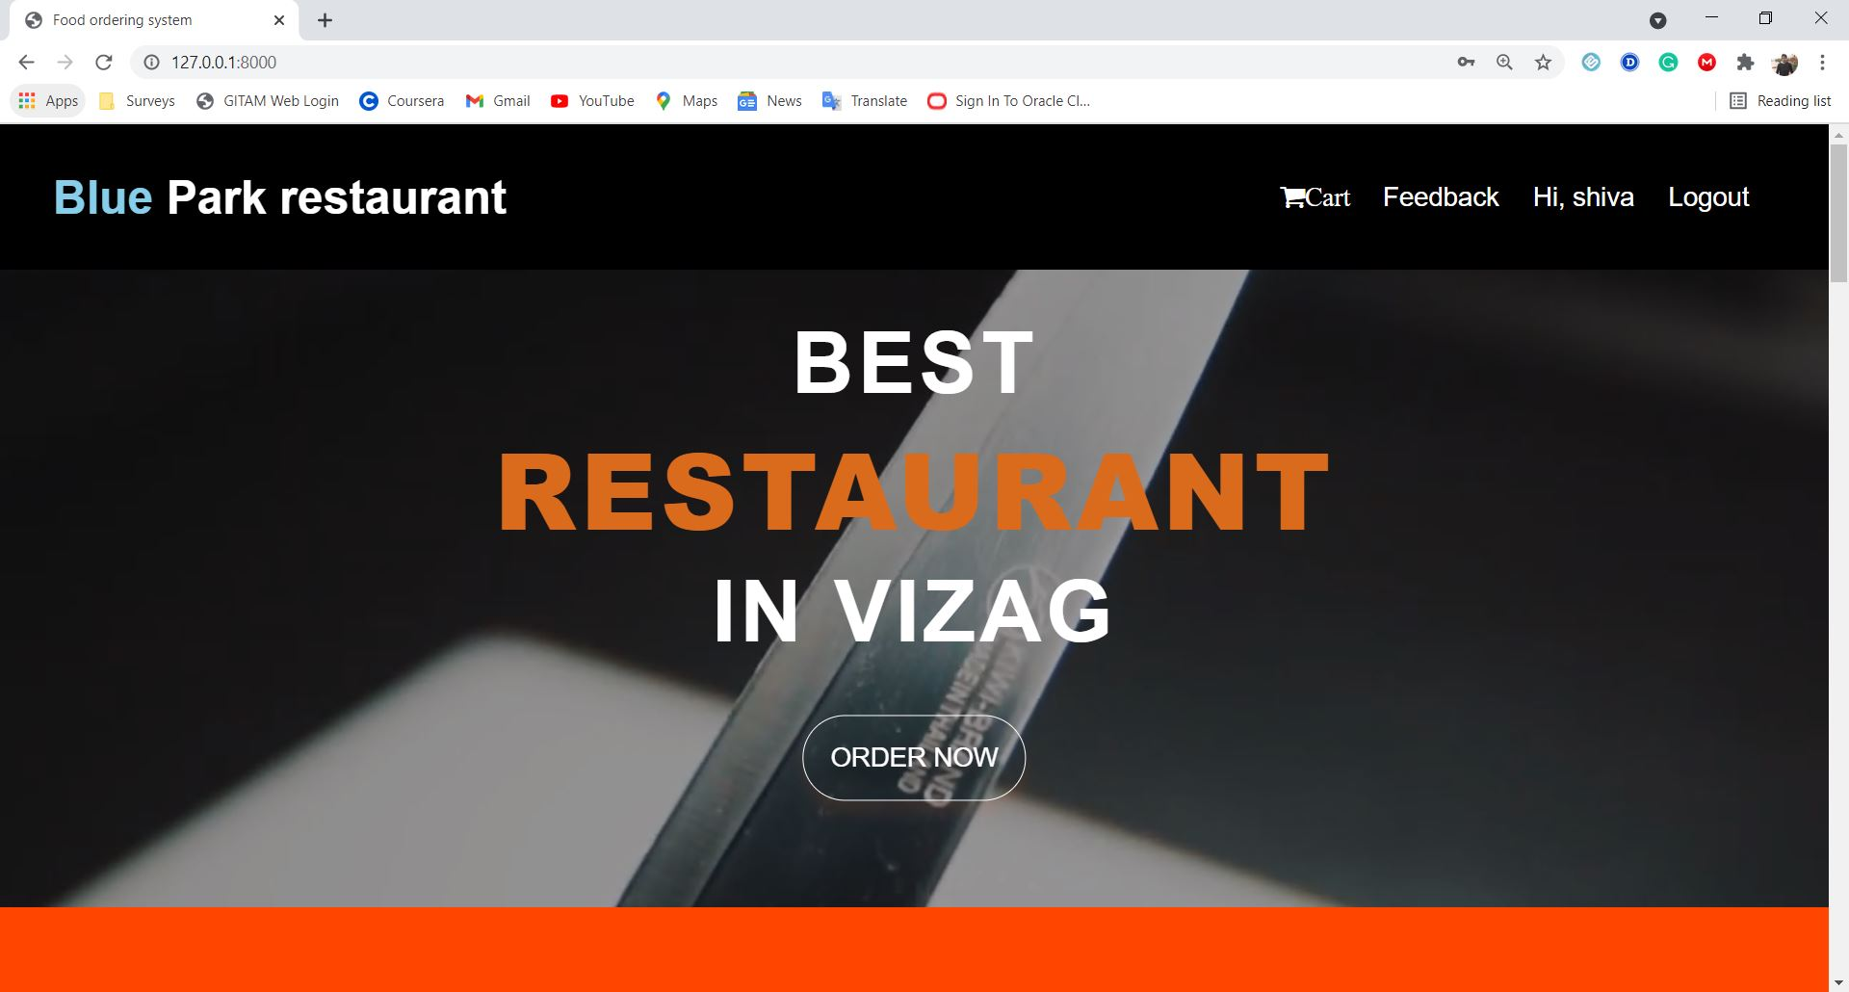

#6 Menu Pages:
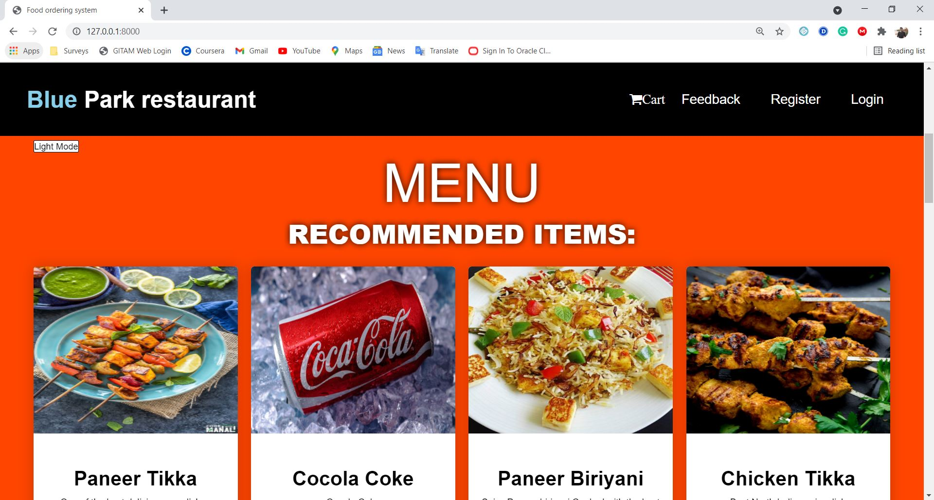
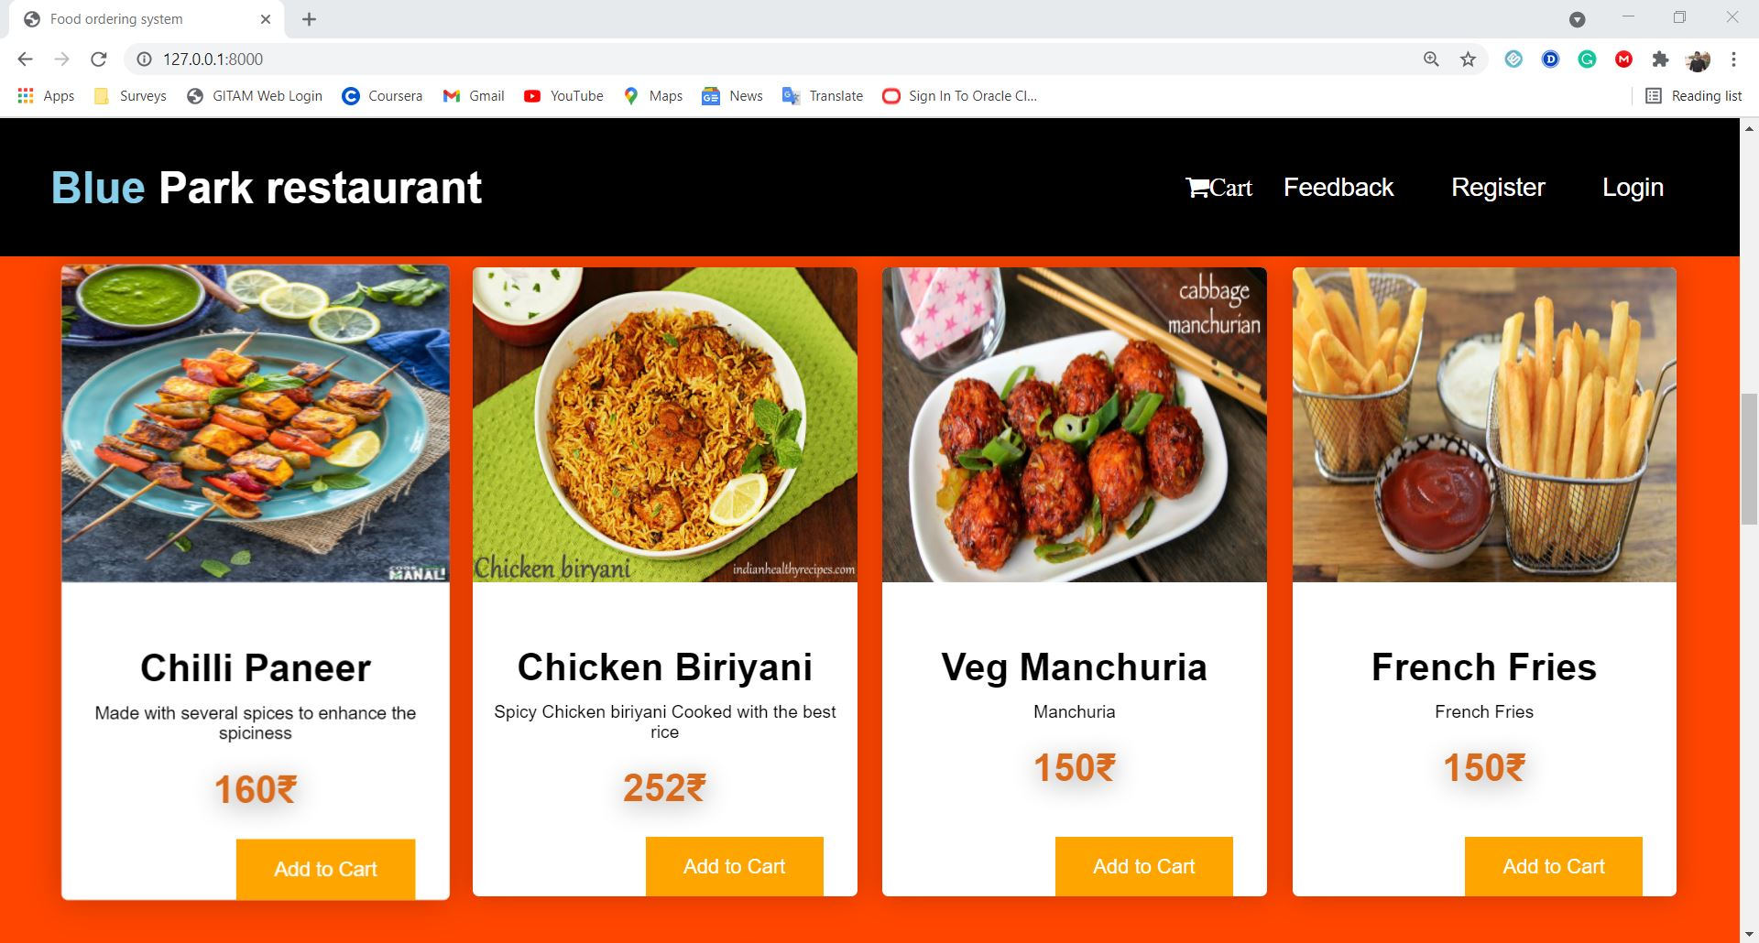

#7 Cart Pages:
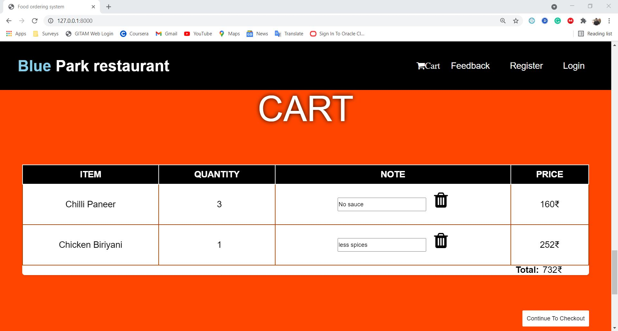
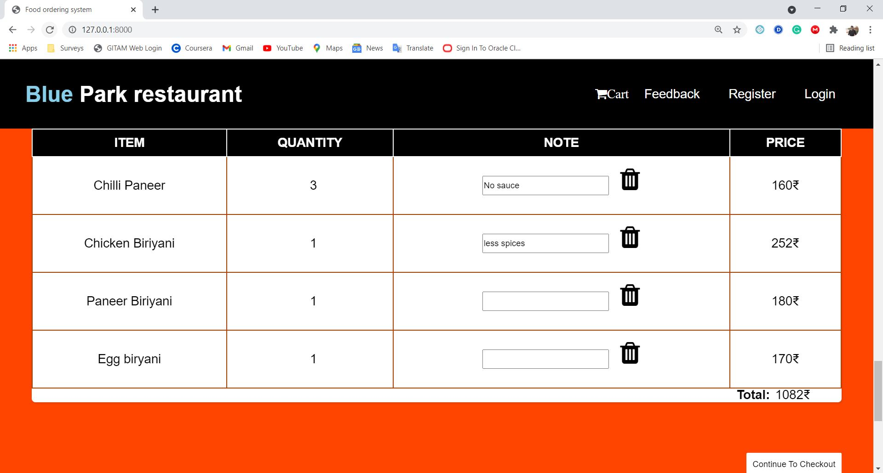

#8 Footer:
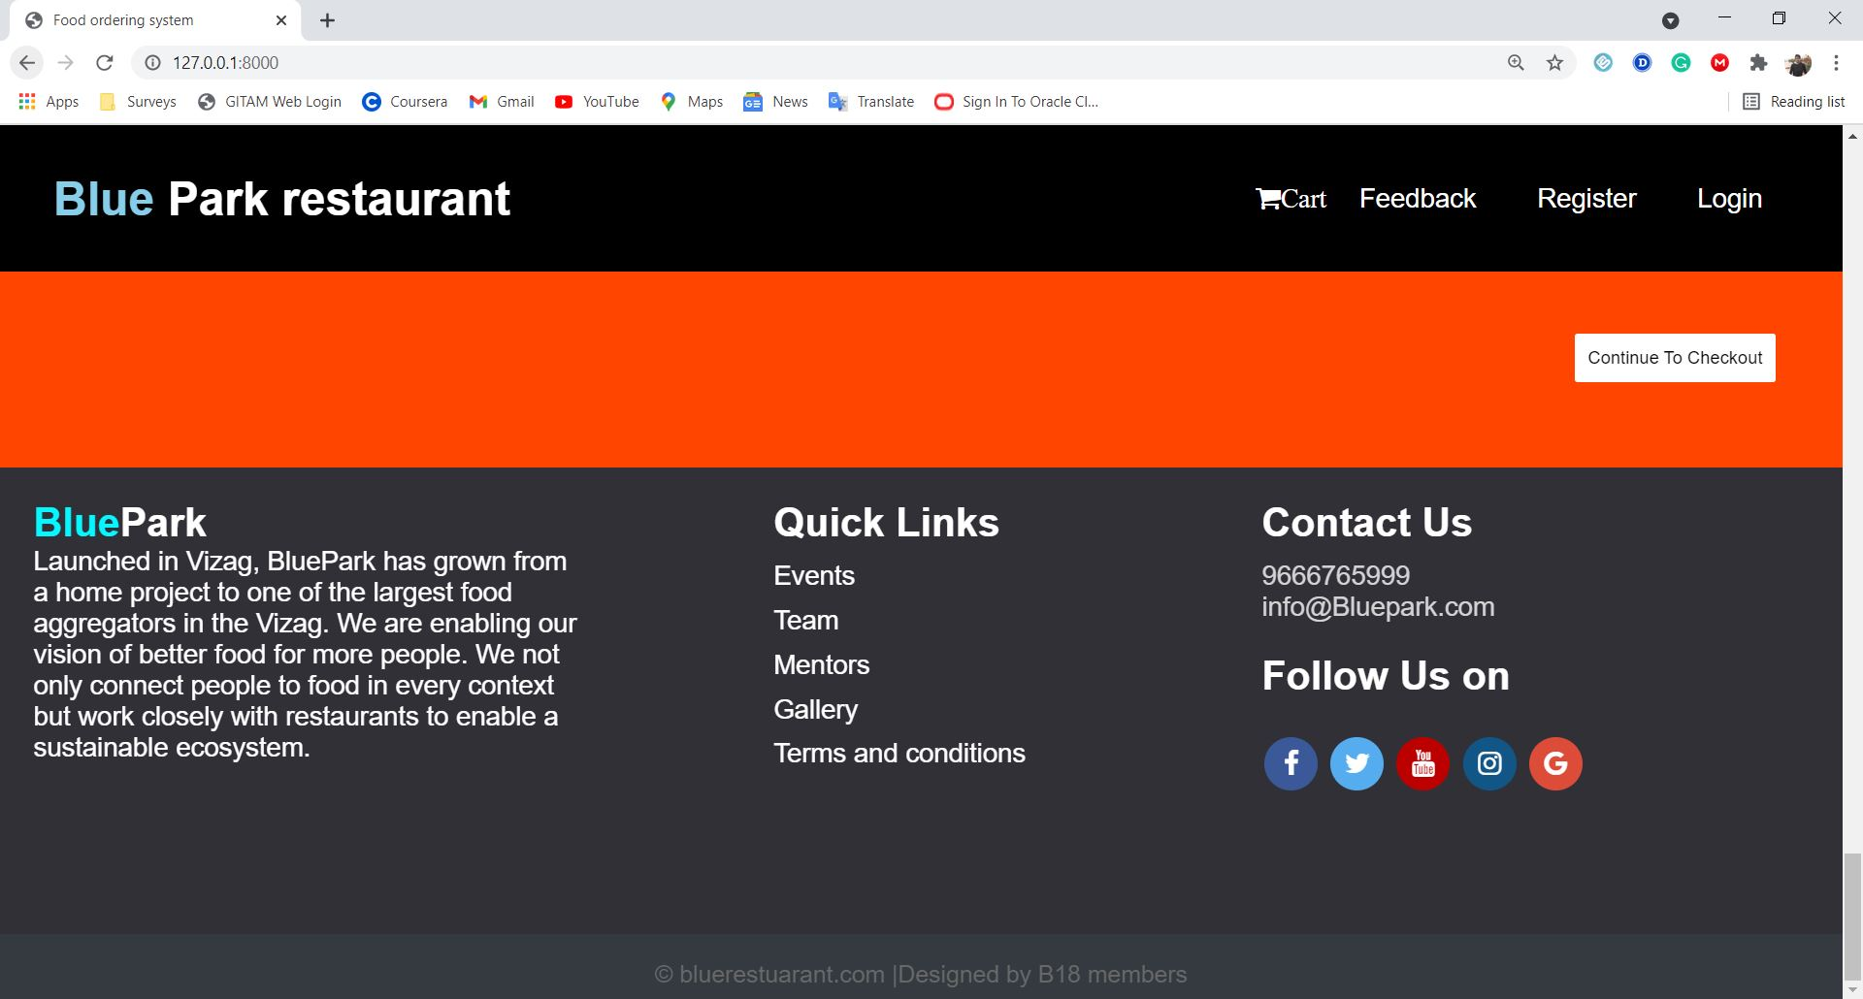

#9 Checkout Page:
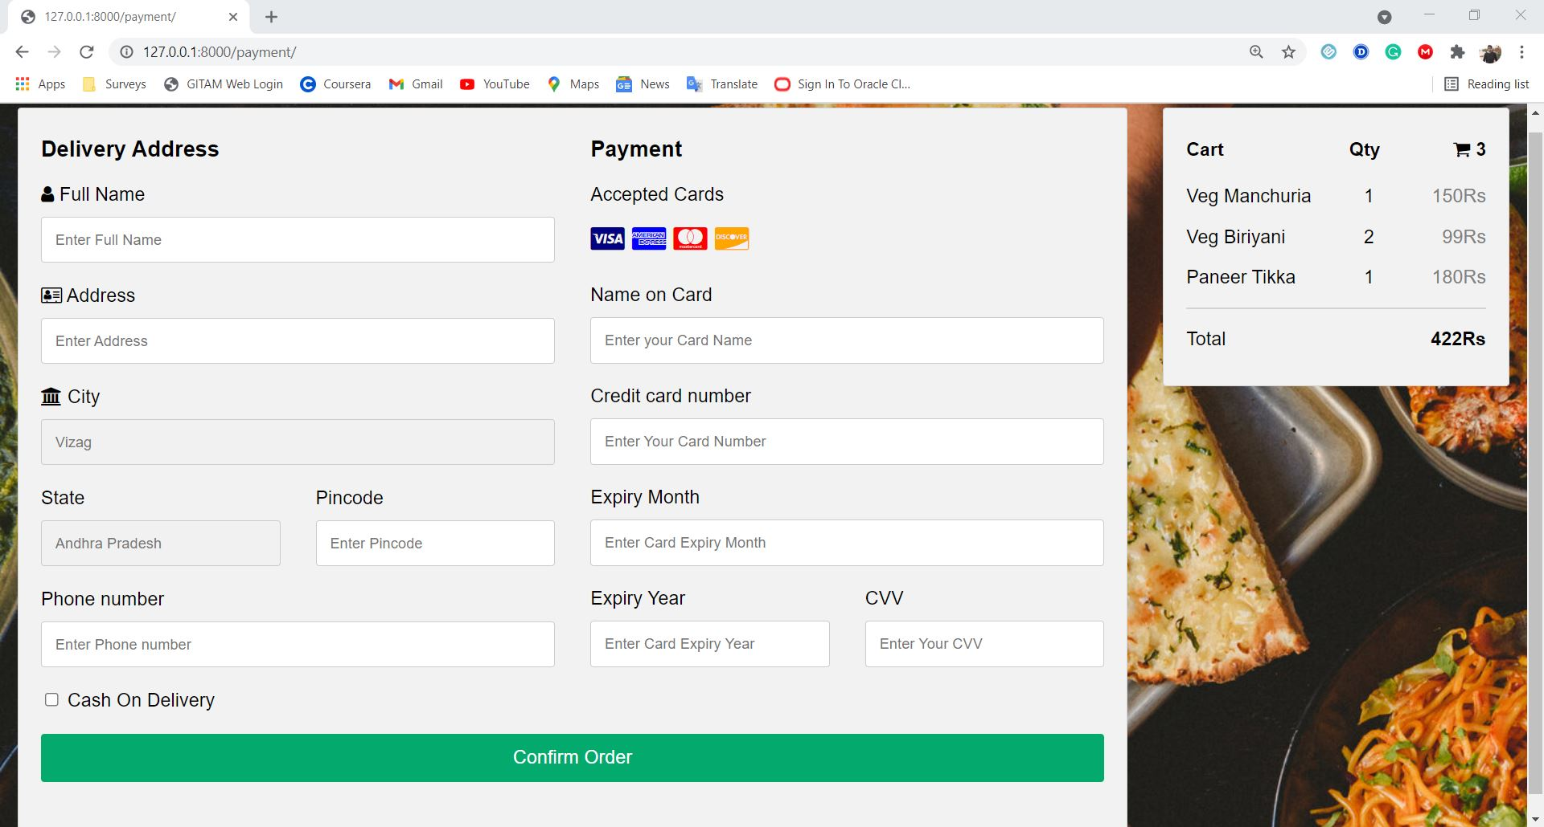

#10 Waiting Page:
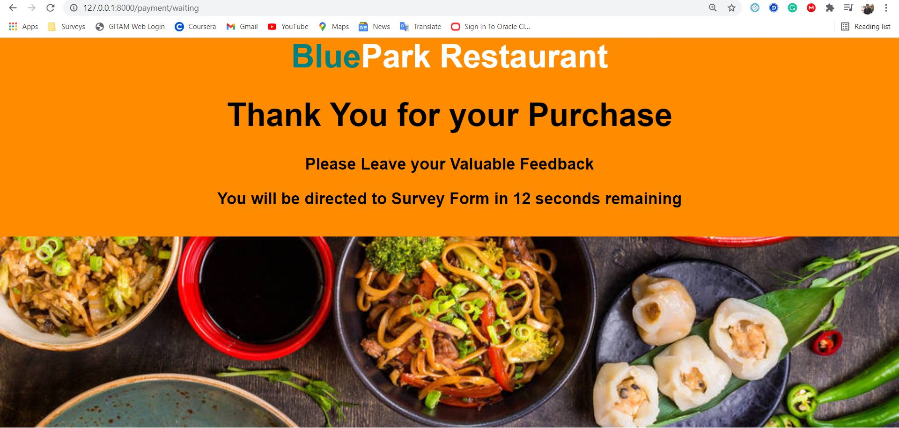

#11 Survey and Feedback Page:
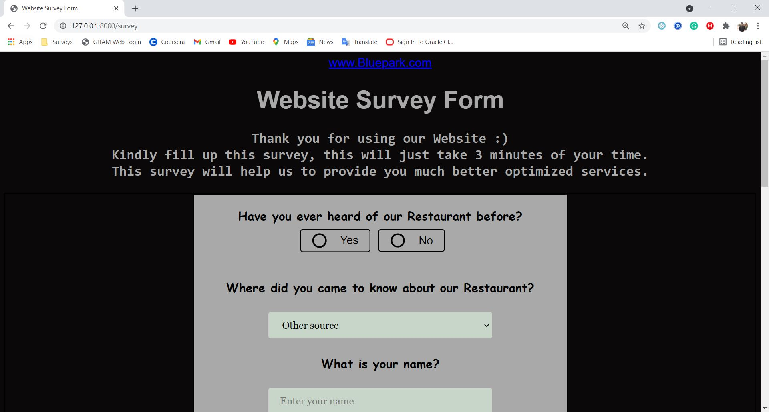

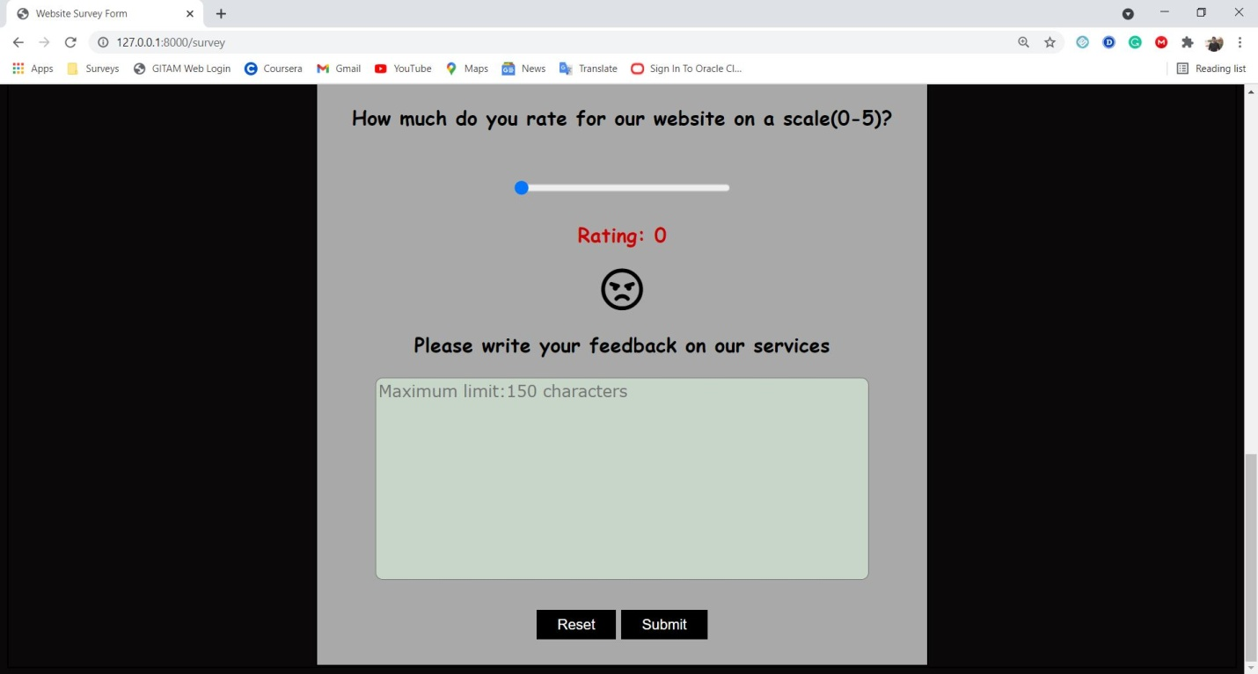

#12 Admin Pages:
